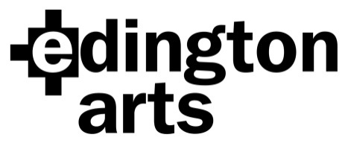

Choral Workshop Saturday 18th May 2019:
Parsons, Purcell and Bruckner
Workshop Leader: Paul Brough

Venue: Edington Priory Church, Monastery Road, Edington, Wiltshire, BA13 4QN
Time: Registration 9.30am: start 10am. Finish: approx. 4.30pm.
Cost: £20 adult, £18 Edington Angels, £10 students in full time education or training.
Copies will be available for hire on the day; please note the Parsons Ave Maria is being prepared specially and is not available retail.

Application Form
Name …………………………………………………Choir/Choral Society……………….………..
Address………………………………………………………………………………………………….
……………………………………………………………… Post Code……………………
Email address…………………………………………………… Phone………………………..

Please specify: Soprano 1………… Alto 1……...… Tenor 1……….. Bass 1………….
Soprano 2 ……….. Alto 2……….. Tenor 2……….. Bass 2…………

Number of tickets at £20……… ..£18………… £10…………… Sub total £……………
I wish to hire copies @ £2 in total £…………….
Total….… £……………..
I am paying by cheque/BACS (please delete as applicable) (BACS Ref: Workshop18)

Signature …………………………………………. Date……………………

Cheques should be made payable to Edington Arts.
Please return your completed form, either by post with your cheque to:
Mrs Anne Curtis, The Wilderness, The Butts, Bratton, Westbury, Wiltshire BA13 4SW
or email it to anne@edingtonarts.org and pay by BACS.
Confirmation will be by email unless you include an SAE with your cheque.

Payment by BACS: Lloyds Bank Sort Code: 30-92-63
Account Name: Edington Arts
Account Number: 40661960

