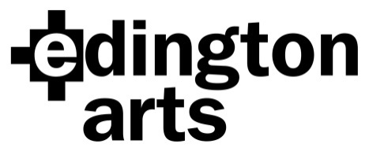

Choral Workshop Saturday 18th June 2016:
Lux Aeterna by Morten Lauridsen
and parts of John Rutter’s Magnificat
Workshop Leader: Brian Kay

Venue: Edington Priory Church, Monastery Road, Edington, Wiltshire, BA13 4QJ
Time: Registration 9.30am: start 10am. Run-through performance 6 – 7pm.
Cost: £20 adult, £18 Edington Angels, £10 students in full time education or training.
Copies of both works will be available for hire on the day, and the Rutter will also be available to buy at £9, which includes a refund of the hire fee plus a discount.

Application Form
Name …………………………………………………Choir/Choral Society……………….………..
Address………………………………………………………………………………………………….
………………………………………………………………… Post Code……………………
Email address ………………………………………………………..Phone………………………..

Please specify: Soprano 1……… Soprano 2 ……… Alto…….. Tenor……… Bass………….
Number of tickets at £20……… £18………… £10…………… Sub total £……………
I wish to hire copies; single hire charge for either or both £2.50 £……….…..
Total….… £……………..
I am paying by cheque/BACS (please delete as applicable) (BACS Ref: Workshop)

Signature …………………………………………. Date……………………

Cheques should be made payable to Edington Arts.
Please return your completed form, either by post with your cheque to:
Mrs Anne Curtis, The Wilderness, The Butts, Bratton, Westbury, Wiltshire BA13 4SW
or email it to anne@edingtonarts.org and pay by BACS.
Confirmation will be by email unless you include an SAE with your cheque.

Payment by BACS: Lloyds Bank Sort Code: 30-92-63
Account Name: Edington Arts
Account Number: 40661960

