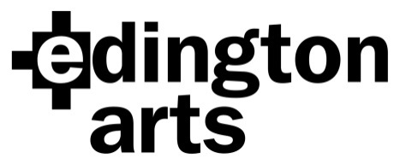

Choral Workshop Saturday 10th June 2017:
Handel’s “Dixit Dominus”
Workshop Leader: Andrew Carwood

Venue: Edington Priory Church, Monastery Road, Edington, Wiltshire, BA13 4QJ
Time: Registration 9.30am: start 10am.
Cost: £20 adult, £18 Edington Angels, £10 students in full time education or training.
Copies will be available for hire on the day, but please feel free to source your own copies. We will be using the Barenreiter edition.

Application Form
Name …………………………………………………Choir/Choral Society……………….………..
Address………………………………………………………………………………………………….
……………………………………………………………… Post Code……………………
Email address…………………………………………………… Phone………………………..

Please specify: Soprano 1……… Soprano 2 ……… Alto…….. Tenor……… Bass………….

Number of tickets at £20……… ..£18………… £10…………… Sub total £……………
I wish to hire a copy/ies @ £2 £…………….
Total….… £……………..
I am paying by cheque/BACS (please delete as applicable) (BACS Ref: Workshop)

Signature …………………………………………. Date……………………

Cheques should be made payable to Edington Arts.
Please return your completed form, either by post with your cheque to:
Mrs Anne Curtis, The Wilderness, The Butts, Bratton, Westbury, Wiltshire BA13 4SW
or email it to anne@edingtonarts.org and pay by BACS.
Confirmation will be by email unless you include an SAE with your cheque.

Payment by BACS: Lloyds Bank Sort Code: 30-92-63
Account Name: Edington Arts
Account Number: 40661960

