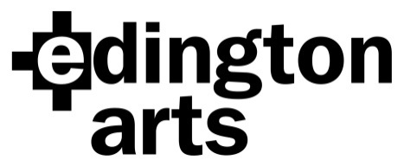

Choral Workshop Saturday 26th June 2021:
Britten’s ‘Rejoice in the Lamb’ and
Elgar’s ‘Great is the Lord’
Workshop Leader: Jeremy Summerly

Venue: Edington Priory Church, Monastery Road, Edington, Wiltshire, BA13 4QN
Time: Registration 9.30am: start 10am. Finish: approx. 4.30pm.
Cost: £20 adult, £18 Edington Angels, £10 students in full time education or training.
Copies will be available for hire on the day, see below.

Application Form
Name …………………………………………………Choir/Choral Society……………….………..
Address………………………………………………………………………………………………….
……………………………………………………………… Post Code……………………
Email address…………………………………………………… Phone………………………..

Please specify: Soprano 1 ………… Alto 1 ……...… Tenor ……….. Bass ………….
Soprano 2…………. Alto 2……….
Number of places at £20……… ..£18………… £10…… Sub total £……………
I wish to hire Britten @ £1.25 £……………
I wish to hire Elgar @ £1.25 £…………….
Total £……………..
I am paying by cheque/BACS (please delete as applicable) (BACS Ref: Workshop21)

Signature …………………………………………. Date……………………

Cheques should be made payable to Edington Arts.
Please return your completed form, either by post with your cheque to:
Mrs Anne Curtis, The Wilderness, The Butts, Bratton, Westbury, Wiltshire BA13 4SW
or email it to anne@edingtonarts.org and pay by BACS.
Confirmation will be by email unless you include an SAE with your cheque.

Payment by BACS: Lloyds Bank Sort Code: 30-92-63
Account Name: Edington Arts
Account Number: 40661960

