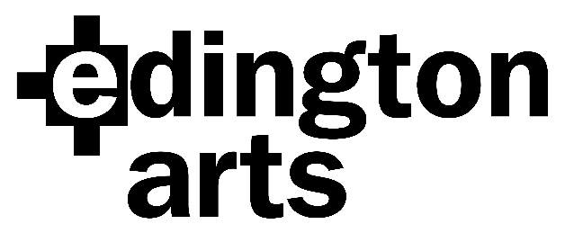

Plainchant Workshop with Peter Stevens
Saturday 12th March 2022
The Priory Church, Edington, Wiltshire BA13 4QN

Registration from 2pm in the Priory Church; workshop runs from 2.30pm finishing at 5.30pm. Compline will be at 6.30pm.

Cost of the workshop is £10, (£5 for students in full time education or training) including music and mid-afternoon refreshments. There will be tea and cake at 5.30pm for a small donation; friends and family are warmly invited to come and stay for Compline.

This is one of the rare choral workshops where both your ability to sight read and your voice part are not too important!

NAME…………………………………………………………………………………………………………….

ADDRESS…………………………………………………………………………………………………………
………………………………………………………………… Phone number:……………………………
EMAIL……………………………………………………………………………………………………………..

I am paying by BACS transfer/cheque. (Please delete as appropriate.)
BACS details: Sort Code: 30-92-63
Account No:40661960
Cheques payable to Edington Arts.

Please note that we will not bank your cheques until we are absolutely sure that there will be no Covid interventions resulting in cancellation; BACS payments will be refunded.

Please return the form to Anne Curtis, The Wilderness, The Butts, Bratton, Westbury BA13 4SW or email it to anne@edingtonarts.org

Registered Charity No: 1187289

