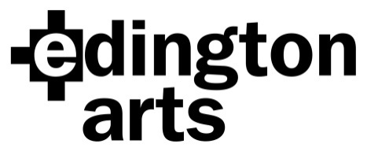

Choral Workshop Saturday 22nd October 2022:
Britten’s ‘Rejoice in the Lamb’ and
Elgar’s ‘Great is the Lord’
Workshop Leader: Simon Carrington

Venue: Edington Priory Church, Monastery Road, Edington, Wiltshire, BA13 4QN
Time: Registration from 9.30am: start 10am. Finish: approx. 4.30pm, run-through at 5pm
Cost: £25 adult, £22.50 Edington Angels, £10 students in full time education or training; includes hire of both copies, arrival and mid-morning refreshments.

Application Form
Name …………………………………………………Choir/Choral Society……………….………..
Address………………………………………………………………………………………………….
……………………………………………………………… Post Code……………………
Email address…………………………………………………… Phone………………………..

Please specify: Soprano 1 ………… Alto 1 ……...… Tenor ……….. Bass ………….
Soprano 2…………. Alto 2……….
Number of places at £25……… ..£22.50………… £10…… Sub total £……………
Total £……………..
I am paying by cheque/BACS (please delete as applicable) (BACS Ref: Workshop22)

Signature …………………………………………. Date……………………

Cheques should be made payable to Edington Arts.
Please return your completed form, either by post with your cheque to:
Mrs Anne Curtis, The Wilderness, The Butts, Bratton, Westbury, Wiltshire BA13 4SW
or email it to anne@edingtonarts.org and pay by BACS.
Confirmation will be by email unless you include an SAE with your cheque.
Payment by BACS: Lloyds Bank Sort Code: 30-92-63
Account Name: Edington Arts
Account Number: 40661960

Registered Charity No:1187289

